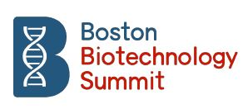

SUMMIT REPORT

The 3rd Boston Biotechnology Summit, was successfully held, on 2 June 2019 at the renowned Wistar Institute in Philadelphia PA, USA, a prelude to the 2019 International BIO Convention.
Introduction: 2019 Central Theme <COLLABORATION>

Founded in 2016, the Boston/Paris Biotechnology Summit® is an exclusive, Trans-Atlantic Bridge designed to foster innovative synergies between biotech and pharma companies, healthcare-focused cities and regional clusters, institutional, philanthropic and strategic investors. The Summit®'s intent is to spark projects, their financing and strategic deals in order to solve unmet medical needs and globally improve the lives of patients. The central theme of the first edition was an introduction to the biotechnology ecosystems in Boston and Paris, which were also highlighted in terms of innovation and leadership. The Summit®’s framework for its 2018 edition was “from the promise of raising capital to the reality of clinical trials” and featured speakers from the academic, biotech, investor, legal/regulatory and pharma worlds. A CEO “pitching session” was introduced. The objective of the third Summit was to further ensure that it could offer an efficient and cost-effective forum which will add value for the companies taking part. To achieve this, the organizers’ aim was to maintain a rich content and a “human size” and to strategically expand this US-based Summit® to broader European participation. An International Program Committee was also set up.
The central theme of the 3rd edition was therefore “Collaboration”.
A recent review in the New England Journal of Medicine focused on three diseases — cystic fibrosis, multiple myeloma, and type 1 diabetes mellitus — to illustrate how collaborations between academic institutions, foundations and industrial partners have evolved to address the therapeutic challenges of these conditions, with the “Patient” consistently at the heart of the collaborative model. The remarkable scientific progress achieved in the biotech industry needs to be matched by advances in developing business models that are appropriate to the industry.
Collaboration is becoming an increasingly important component in the next stage of biotechnology's evolution, for at least three fundamental reasons:
- First, no single technology is likely to generate all the drug innovations required to treat the complex range of diseases that constitute unmet medical needs in our societies.
- Second, no single company or type of company can possibly possess all the answers, and,
- Third, the risky nature of the economics of biotechnology is such that no single region can achieve results on its own.

Soheila Gharakhanian, BS, Summit Co-Founder and President of Blend of Concept LLC (the conference producer) opened the event by describing its mission and historical background. Slide 1 shows the three Summit venues used in 2017-2019. Particular thanks were extended to the Sponsors that have supported the Summit’s organization during the past three years: McDermott Will and Emery, IPSEN, 4Clinics, Nanobiotix, CPL Physicians and Genopole. | 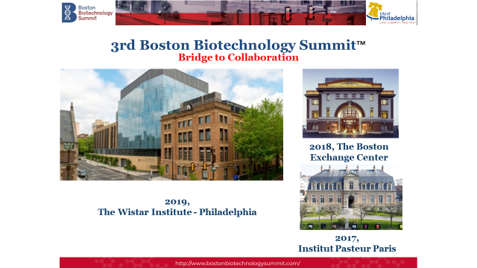

In 2019 Participants came from the US (CT, GA, MA, NY, PA, SD, TX …), Canada and Europe (Belgium, France, Germany, Norway, Sweden, Switzerland, etc.).

Slide 2:
Corporations/Organizations represented at the 3rd Boston Biotechnology Summit
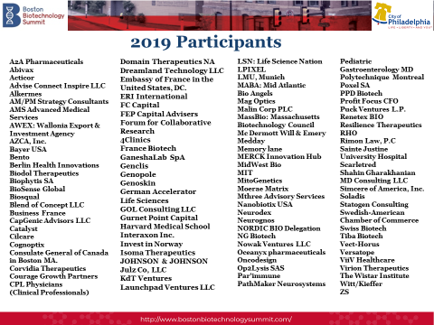
Pravin Chaturvedi, PhD, 2019 Guest Program Chair, stated: “The biotechnology industry faces both opportunities and challenges in terms of technology and finance. Our success will always depend on the quality of collaborative efforts. For this reason, as Guest Program Chair, I believe in the importance of in-depth debate on this central theme at the Boston Biotechnology Summit on June 2 in Philadelphia. We have therefore invited our colleagues to attend and participate fully in these discussions” [Press Release, 15/30 May 2019].

Shahin Gharakhanian, MD, DPH, Summit Co-Founder and Program Chair, pointed out that the current complexity of clinical development was a major reason to enhance collaboration.
Slide 3:
Complexity of Clinical Development
Shahin Gharakhanian cited examples of phase II and II studies but also pointed to the continuum of clinical development from registration studies to RWE: Real World Evidence [Slide 3] | 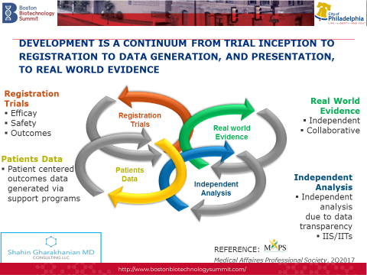

Sessions ❶ to ❺

The different session headings are summarized below:

Session  I | - Opening Statements: What do we want to achieve?  - The WISTAR Institute Model for Collaboration and Curing Chronic Diseases.
Session II | The Evolution of Collaboration in Biopharma.
Session III | Collaborating in an era of high data volumes will be enabled via Artificial Intelligence, Big Data analysis & Digital technologies; how will the optimal delivery of innovative treatments to patients evolve globally? What challenges do we face?
Session IV | Which collaborative approaches will Improve CNS: Central Nervous System, Neurological and Aging-related Complications?
Session V | Have we optimized the Potential of Immune-Based Treatments in Infectious Diseases, Chronic Inflammation & Oncology?

[Session I] Heather Steinman, PhD, MBA, Vice President for Business Development and Executive Director of Technology Transfer at The Wistar Institute, the nation’s top independent research institution devoted solely to biomedical science and a world leader in cancer, immunology, virology and infectious disease research, was the first speaker at the podium. She explained that the Institute is committed to accelerating research advances from bench to bedside through brilliant science and distinctive approaches to collaboration among scientific investigators and academic and industrial partners. Wistar’s single-minded focus is on making discoveries that will change the future of human health.

Slide 4:
Conclusions from Luis Montaner
Luis J. Montaner D.V.M., D.Phil. Vice President, Scientific Operations, the Wistar Institute, Herbert Kean, M.D., Family Endowed Chair Professor, Director, HIV-1 Immuno-pathogenesis Laboratory Professor, Immunology, Microenvironment & Metastasis Program. His talk on “Collaborate – Innovate – Translate” concerned the Wistar Institute model and experiences. Dr Montaner indicated that collaborations grow in proportion to three elements: (1) clarity of scientific vision, (2) leadership that can inspire others to join the fight not because it will succeed but because it is worth doing, (3) evolution potential for ideas to come in or out of groups. | 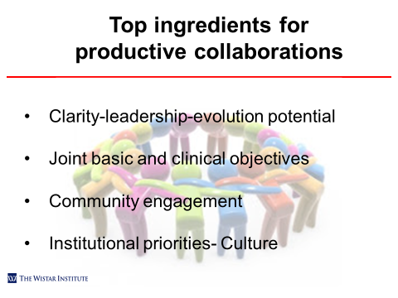

[Session II] The first panel on “The Evolution of Collaboration in Biopharma” comprised the following experts and executives:
Pravin Chaturvedi, PhD, CEO & Co-founder, Oceanyx Pharmaceuticals, Woburn MA; Horst Domdey, PhD, BIO^{M} (Munich Biotechnology Cluster) & Bavarian Biotechnology Network and Professor, LMU Munich, Germany; John Hallinan, Chief Business Officer, MassBIO (Massachusetts Biotechnology Council), Boston MA; Sophie Kornowski, PharmD, Senior Partner, Gurnet Point Capital, Cambridge MA, and John Pottage, MD, Senior Vice President, Chief Scientific & Medical Officer, ViiV Healthcare [GSK, Pfizer, Shionogi Joint Venture], Collegeville, PA.

The panel was moderated by Jennifer Chase. Managing Director, Global Life Sciences Practice, Witt/Kieffer International Ltd, Burlington MA, USA; Pierre Courteille, R.Ph, MBA, Vice-President, France-Biotech, Paris, France and Annika Pierson, Chief Operating Officer, German Accelerator Life Sciences, Cambridge MA, USA.

The key topics addressed by this panel included:
- “Champions to drive Collaboration”
- “Courage” as a driver of Leadership
- “There is no one leadership style that works”,
- “Shared Vision” to succeed in collaborations,
- “Trust”, and,
- “Understanding the codes used in companies in order to establish effective collaboration”.
The panel also discussed examples of both successful and unsuccessful collaboration experiences.

[Session III] The second panel on “Collaborating in an era of high data volumes will be enabled via Artificial Intelligence, Big Data analysis & Digital technologies; how will the optimal delivery of innovative treatments to patients evolve globally? What challenges do we face? Involved the following experts and executives:

Elena Diez, PhD, Co-Founder & Sr. Management Team Member, A2A Pharmaceuticals, Computational Systems & Artificial Intelligence Platform, New York, NY; Lizabeth Leveille, Associate Vice President, Head, Boston Innovation Hub Business Development & Licensing, MERCK Research Laboratories, Boston MA; Philippe Jouvet, MD, PhD, Research Center in Cyber-Infrastructure & HTAU (Health Technologies Assessment Unit), Professor of Pediatrics. University of Montreal, Canada; Dale C Van Demark, Partner, McDermott Will Emery, Washington DC; Veronica Miller, MD, Executive Director, Forum for Collaborative Research, Washington DC & Adj. Professor, University of California, Berkley CA,, and Patrick Tricoli, PharmD, MBA, CEO Nanobiotix USA, Nanobiotix Corp, Paris, FR & Cambridge MA.

The panel was moderated by Pravin Chaturvedi, CEO, Oceanic Pharmaceuticals, Woburn MA and 2019 Guest Program Committee Chair; and Christine Sarkissian, International Business Development, Co-founder, Canadian Technology Accelerator. Consulate General of Canada, Boston MA [Denis Gauverau, PhD, Director of Innovation & Business Development, Polytechnique Montreal, Canada, contributed to preparing the panel].

“The accelerating creation of vast quantities of healthcare data will fundamentally change the nature of medical care. The key distinction between traditional approaches and machine learning is that in the latter case, a model learns from examples rather than being programmed with rules (Rajkomar A, et al. Machine Learning in Medicine 2019 New England Journal of Medicine)”. Artificial intelligence (AI), is defined as the ability of a digital computer or computer-controlled robot to perform tasks that are commonly associated with intelligent beings. The term is frequently applied to projects on the development of systems endowed with the intellectual processes characteristic of humans, such as an ability to reason, discover meaning, generalize or learn from past experience.

The Panel’s objective was to debate the impact on human collaboration of the large quantities of data available via various data technologies including, but not limited to, Artificial intelligence (AI), and Machine Learning:.
- Physicians need to deal with the complex collection of information in order to make decisions … AI therefore focuses on helping decision making. One published example is to use machine learning models to predict oxygen saturation in critically ill children (Ghazal S…. PA Jouvet et al., 2019)
- The issue of the quality control and validation of algorithms used in AI and machine learning was emphasized.
- The acceleration of lead identification and of de-risked and more efficient pre-clinical development is a significant area of AI application.
- The improved and more efficient use of clinical trial data was emphasized.
- From a corporate business perspective, the use of AI to complete tasks and accelerate workflows was also discussed.
[Session IV] The third Panel on “Which Collaborative approaches will Improve CNS: Central Nervous System, Neurological and Aging-related Complications?” took the form of a pitching session focused on this area. The panel comprised the following experts: Gilles Avenard, MD, CEO Acticor, 2018 Best-Biotechnology-Entrepreneur Awardee, Paris, France; Olivier Blin, MD, PhD, Professor of Clinical Pharmacology/Neurology, Aix-Marseille University, Marseille, France and Member of the EU Scientific Committee Initiative for Innovative Medicines; Paul Hartung, Representing Launchpad Venture LLC, Angel Investment Group, Boston MA; Lizabeth Leveille, Associate Vice President, Head, Boston Innovation Hub Business Development & Licensing, MERCK Research Laboratories, Boston MA; Maria Lopez-Bresnahan, MD, Vice-President, Clinical Research for Neurology, ALKERMES, Waltham MA and Bernard “Bernie” Rudnick, MBA, Angel Investor & Business Strategist, MABA (Mid Atlantic Bio Angel Group), Newark DE.
The panel was moderated by Cynthia “Cindy” Lander, PhD (Neurosciences), CEO Moerae Matrix, Partner, Nascent Enterprises, Boston MA and Michael Nowak, PhD, Managing Partner, Nowak Ventures LLC, Wellesley MA & CEO, Navan Technologies, Inc., San Francisco, CA. The session was prepared with the collaboration and expertise of Retsina Meyer, PhD, Neuroscientist-Entrepreneur, Cambridge MA.

Five innovative and award-winning companies made presentations, which were followed by a discussion:

Slide 5: Companies presenting during Session 5 at the 3rd Boston Biotechnology Summit
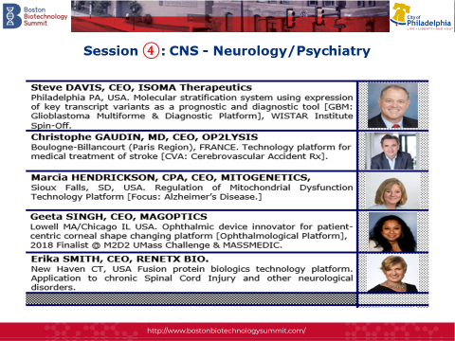

[Session V] the final Panel on “Have we optimized the Potential of Immune-Based Treatments in Infectious Diseases, Chronic Inflammation & Oncology? was a pitching session dedicated to Infectious Diseases, Immunotherapy and Vaccines.

The panel comprised the following experts: Marion Hitchcock, PhD, Global External Innovation & Alliances, Bayer USA, Cambridge MA; Sophie Kornowski, PharmD, Senior Partner, Gurnet Point Capital, Cambridge MA; Greg Mannix, Vice-President, LSN (Life Sciences Nation), Boston MA; Veronica Miller, MD, Executive Director, Forum for Collaborative Research, Washington DC; Nicolas La Monica, PhD, Senior Director, Infectious Diseases @ Johnson & Johnson, Boston MA, and John Pottage, MD, Senior Vice President, Chief Scientific & Medical Officer, ViiV Healthcare, Collegeville, PA. The panel was moderated by Stephan Ogenstad, PhD, President, Statogen Consulting LLC, NC, Formerly, Advisor to Sweden’s Nobel Prize Committee for Medicine and Frederick “Rick” Pierce II FEP Capital Advisors, Cambridge MA, New York, Beijing, Shanghai. Regulatory insights were offered by Khelin Aiken, McDermott Will Emery, Washington DC. This session was prepared with the collaboration/expertise of Shahin Gharakhanian MD, DPH, Infectious Diseases & Pharmaceutical Medicine, Cambridge MA.

Five innovative and award-winning companies made presentations, followed by a discussion:

Slide 6: Companies presenting during Session 6 at 3rd Boston Biotechnology Summit
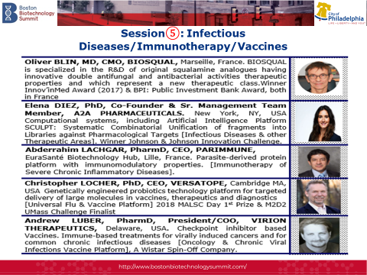

During the opening and closing session of the 3rd Boston Biotechnology Summit, the International Program Committee described what was to be achieved during the day and concluding as to the importance of collaboration as a complement to finance and technology.
Summit Sponsors: [Platinum Sponsors] McDermott Will Emery, The Wistar Institute, IPSEN, [Gold Sponsors] 4Clinics, Nanobiotix, [Silver Sponsor] CPL Physicians, [Biotechnology Circle Sponsors] Genopole, German Accelerator Life Sciences, PPD Biotech, RHO, [Friends of Summit Sponsors] Concord Insurance Group, Consulate General of Canada, Boston MA.
Media Activities: BIOTECH FINANCES, Linked In Postings, PBJ: Philadelphia Business Journal, Press Releases [Cambridge MA, Paris FR], Video Interviews [managed by Dreamland Technologies LLC].

IN CONCLUSION: SUMMIT MISSION

An exclusive, Trans-Atlantic bridge designed to foster innovative synergies between biotech and pharma companies, healthcare-focused cities and regional clusters, institutional, philanthropic and strategic investors. The Summit's intent is to spark projects, their financing and strategic deals in order to solve unmet medical needs and improve patient lives globally.

BIBLIOGRAPHY / REFERENCES

- Boston Biotechnology Summit, 3rd Summit Booklet, Philadelphia PA, 2 June 2019.
- Boston Biotechnology Summit Website: www.bostonbiotechnologysummit.com
- Chase J. Innovation Leadership in Drug Development BioProcess International 2019; 17(4) April 2019.
- Domdey H. Bavarian Biotech Q&A. Nature, 2016; 533:S30-31
- Gautam A. The changing model of Big Pharma: impact of key trends. Drug Discovery Today 2016; 21: 379-384.
- Gersdorf Th et al. Demystifying Academia-Industry Collaboration. Nature Review Drug Discovery, Advance Online Publication 2019.
- Ghazal S, Sauthier M, Brossier D, Bouchir W, Jouvet PA, Noumeir R. Using machine learning models to predict oxygen saturation following ventilator support adjustment in critically ill children: a single center pilot study. PLOS ONE 2019 14(2): e0198921.
- Gower JM. Evolving role of collaboration in biotechnology. Bioentrepreneur 1998; 16: 31-32.
- Grant A. Give & Take: Why helping others drives our success. Penguin Books, 2014.
- HI-PRECIMED Project (France) https://www.usposts.net/2018/09/precision-medicine-cap-digital-and-medicen-team-up-with-oncodesign-servier-and-intersystems-on-hu-precimed-project/
- Johnson D. Collaboration is the key to innovation in biotechnology. BioProcess International 10.14.2016.
- Ramsey BW, Nepom GT, Lonial S. Academic, Foundation and Industry collaboration in finding new therapies. New England Journal of Medicine 2017; 376: 1762-9.
- Rajkomar A, Dean J, Isaac Kohane I. Machine Learning in Medicine 2019 New England Journal of Medicine 2019;380:1347-58.
- PharmaVoice 2019 Year in Review. 10 Trends. PharmaVoice Nov/Dec. 2018; 18: 10 [Special Issue].
- Powell WW, White DR, Koput KW, Owen-Smith J. Network Dynamics and Field Evolution: The Growth of Inter-organizational Collaboration in the Life Sciences. AJS: American Journal of Sociology 2005; 110: 1132-1205.

